Error: Sometimes the following org.testng.TestNGException of cannot find the class in classpath exception occur while running the testng.xml suite.

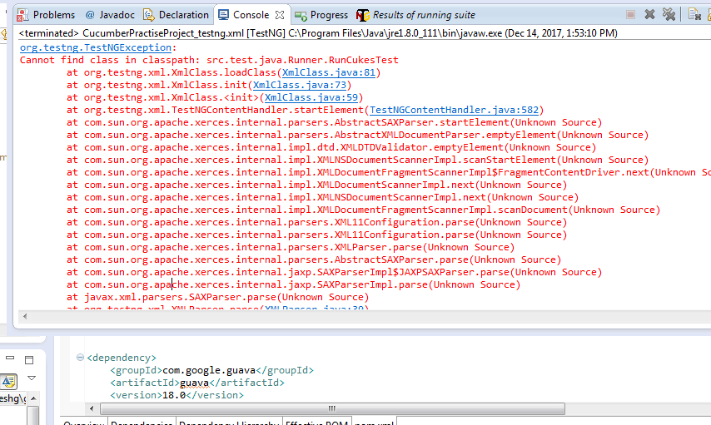

Solution: Steps

1. Right click project 🡪Build Path🡪Configure Build Path
2. Click on Projects Tab and then click on Add button.

Initially, there might be no row in ‘Required Project on the build path’ section.

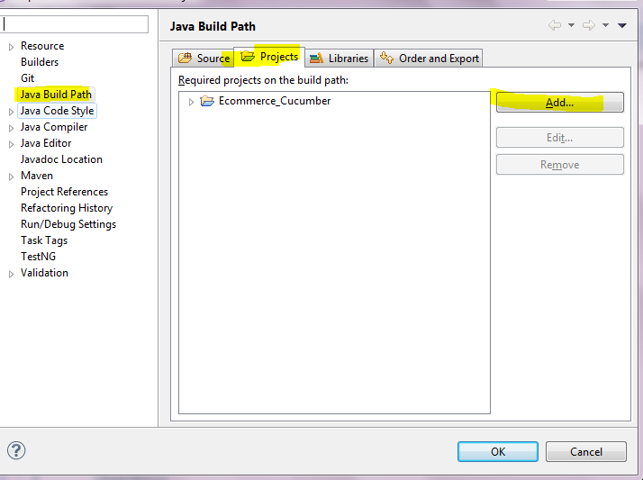

After clicking on Add button, just select the project under which the above exception is occurring.

After adding it, problem will disappear.

Note: TestNG dependency should be added into pom.xml as well.